Powerschool Parent View

Steps to Viewing Grades
- Log into Powerschool at https://ps.willingtonct.org/public/ using your username and password
- Then click on the student that you want to view grades for
- Click on the trimester grade or dash for the course you wish to view
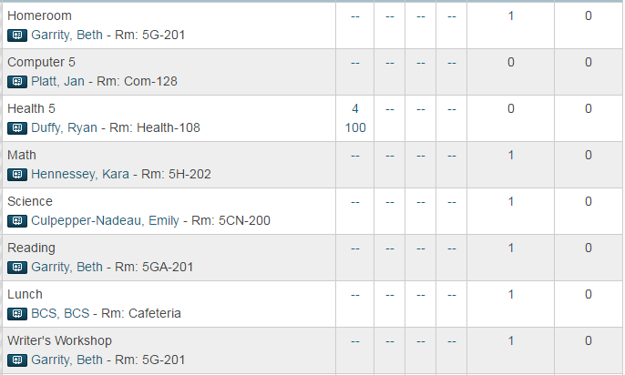

- Here you can view your child’s score on each assignment
